Databases: Allied & Complementary Medicine, British Nursing Collection, Public Health Database

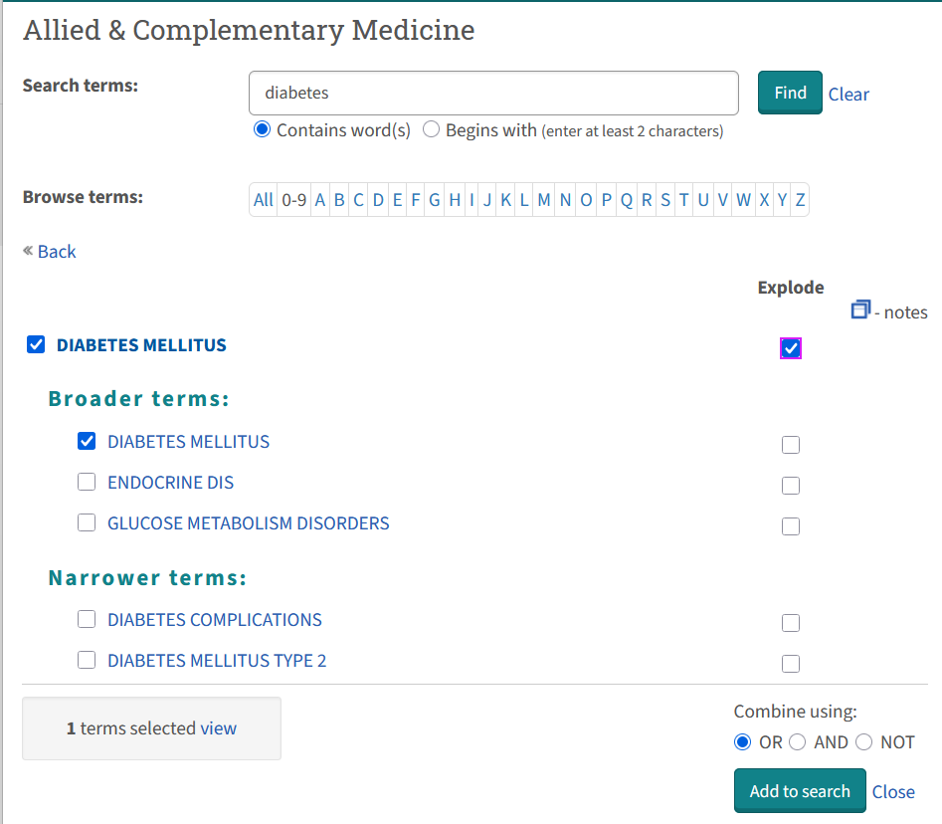

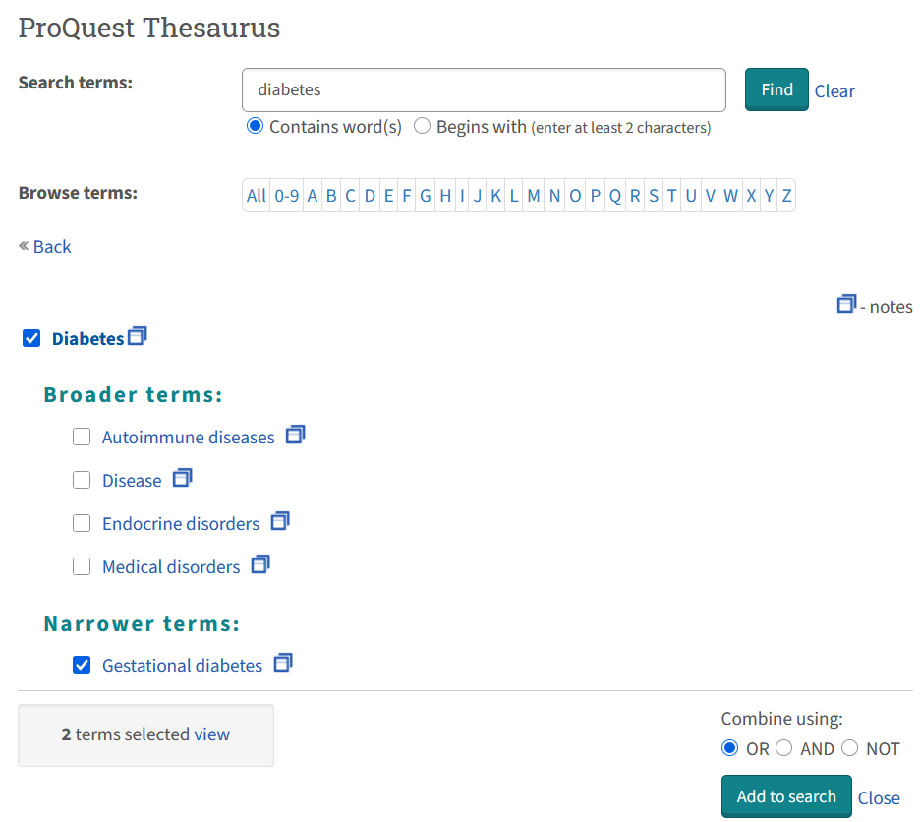
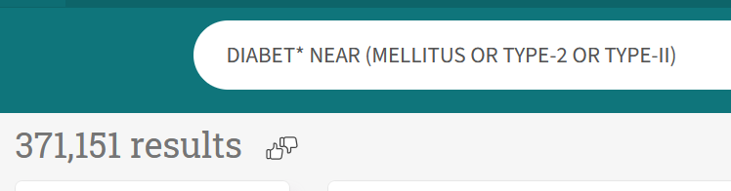
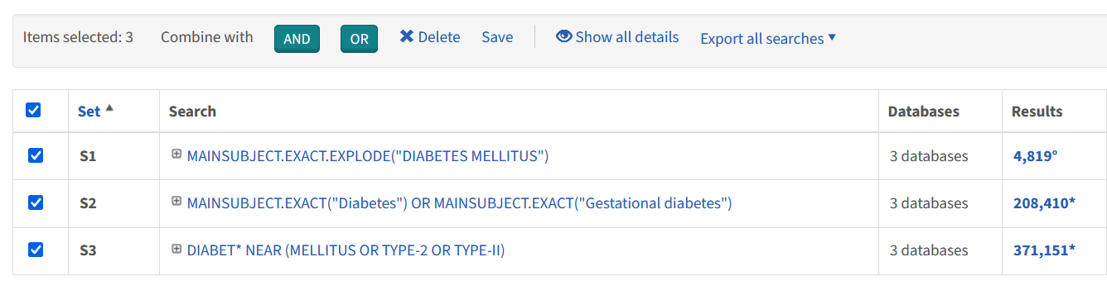
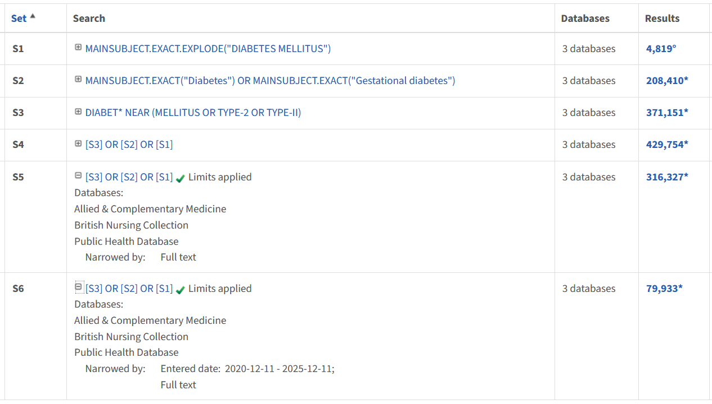

Search Strategy from ProQuest - 2025 December 11
Databases: Allied & Complementary Medicine, British Nursing Collection, Public Health Database

Set# | Searched for | Results
S1 | MAINSUBJECT.EXACT.EXPLODE("DIABETES MELLITUS") | 4819°
S2 | MAINSUBJECT.EXACT("Diabetes" OR "Gestational diabetes") | 208410*
S3 | DIABET* NEAR (MELLITUS OR TYPE-2 OR TYPE-II) | 371151*
S4 | [S3] OR [S2] OR [S1] | 429754*
S5 | [S3] OR [S2] OR [S1] | 316327*
S6 | ([S3] OR [S2] OR [S1]) AND pd(20201211-20251211) + [FullText] | 79933*

* Duplicates are removed from your search, but included in your result count.
° Duplicates are removed from your search and from your result count.

Database split of Set 4: Database split of Set 6:
