Search Strategy from Dialog November 24 2025 08:13
Databases: Allied & Complementary Medicine™

Set# | Searched for | Results
S1 | WEIGHT LOSS DRUGS | 415°
S2 | WEIGHT LOSS DRUG | 415°
S3 | WEIGHT AND LOSS AND DRUG | 415°
S4 | WEIGHT AND LOS* AND DRUG | 439°
S5 | WEIGHT AND LOS* AND (MANAGEMENT OR DRUG) | 582°
S6 | WEIGHT AND LOS* AND (MANAGE* OR DRUG) | 590°
S7 | WEIGHT NEAR LOS* NEAR (MANAGE* OR DRUG) | 17°
S8 | SU.EXACT.EXPLODE("SMOKING") | 692°
S9 | SU.EXACT.EXPLODE("SMOKING") or smok* | 1715°
S10 | (tobacco or nicotin* or smok*) near (dependen* or addict* or abus*) | 91°
S11 | S10 OR S8 | 725°
S12 | diabetes near (mellitus or II) | 4494°
S13 | diabetes near (mellitus or II OR TYPE-2) | 4619°
S14 | therap* | 139874*
S15 | S14 AND S13 | 2717°
S16 | diet* or nutrit* or food | 15023*
S17 | S16 AND S13 | 834°

° Duplicates are removed from the search and from the result count.

S15
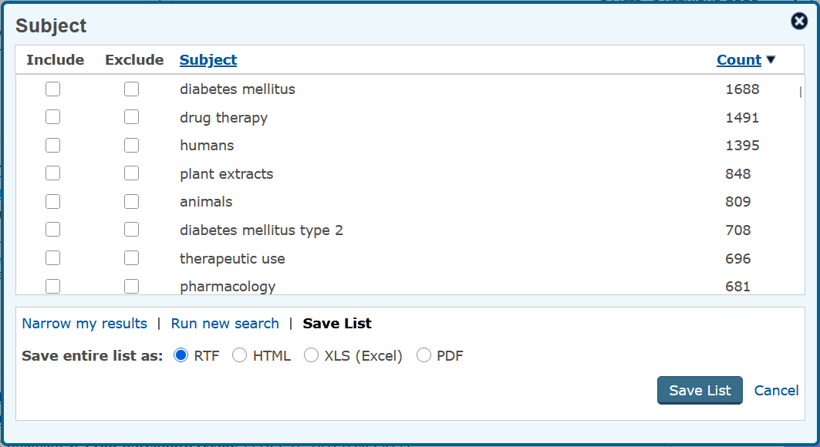

S17
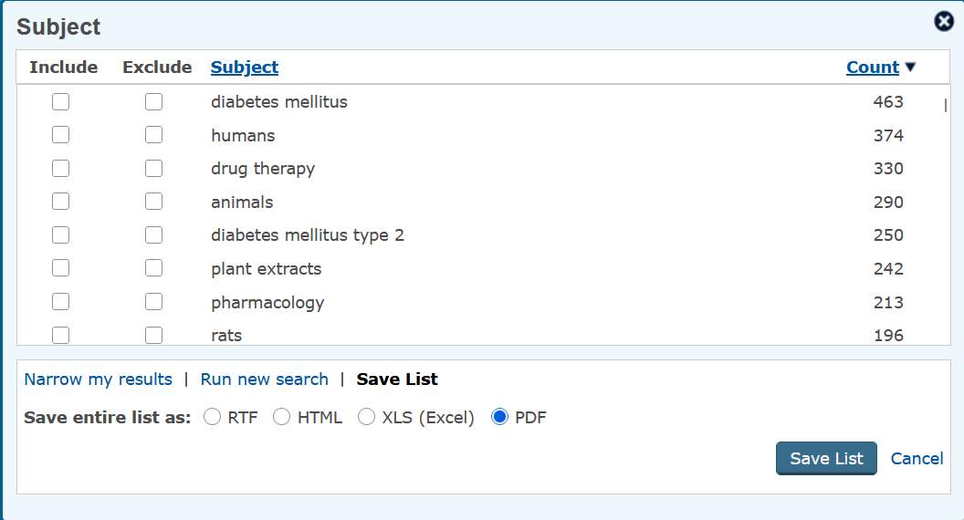

_______________________________________________________________

Contact ProQuest
Copyright © 2025 ProQuest LLC. All rights reserved. - Terms and Conditions

