1. Go to https://www.sciencedirect.com/
2. Click 'sign in'
3. Click 'sign in via your institution'
4. Find 'openathens'
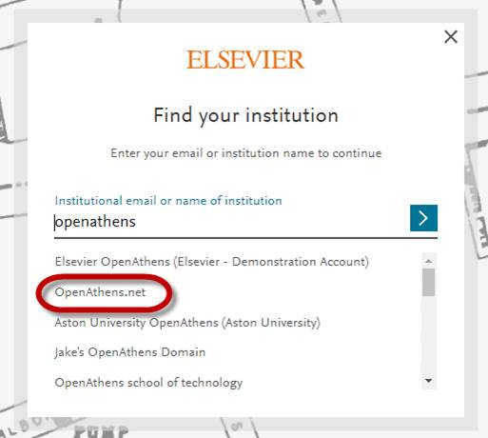
5. Sign in via OpenAthens with your new institutional credentials.
6. When back at ScienceDirect, please add your email address; this must be the same email address you have used in your registration before.
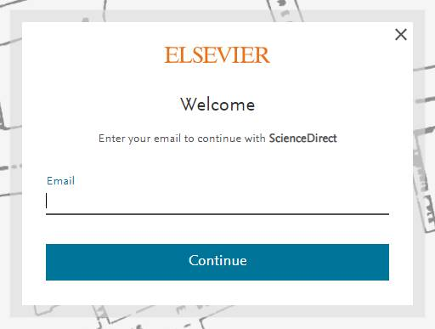
7. Confirm your email
8. Confirm you want to 'Link institution'
9. Continue to ScienceDirect.

